The Political Engagement Activity Student Guide



**CONTENTS**

INTRODUCTION TO THE POLITICAL ENGAGEMENT ACTIVITY…………………………………...3

COMPONENT 1: ENGAGEMENT ………………………………………………………………………..4

COMPONENT 2: COMPLEMENTARY RESEARCH …………….………………………………….….7

COMPONENT 3: THE WRITTEN REPORT …………………………………………………….……….9

ETHICAL GUIDELINES ………………………………….………………………………….…………….10

TIMELINE FOR ENGAGEMENT ACTIVITY COMPLETION…………………………………………..11

ASSESSMENT CRITERIA …………………………………………………………………………….12-14

Course Content Covered ……………..……………………………………………………………….15-20

Key Concepts…………………………………………………………………………………………...21-23

Levels of Analysis………………………………………………………………………………………….24

Example of Completed Engagement Activity with Grades and Comments………………………25-32

Engagement Activity Proposal Form………………………………………………………………….33-35

**INTRODUCTION TO THE POLITICAL ENGAGEMENT ACTIVITY**

**What is the point?**

To quote directly from the IB, ‘the engagement activity provides students an opportunity to explore the central unifying theme of the course – people, power and politics – in practice and outside of the classroom. In the course of their engagement activity, students may, for example, learn about the local manifestations of a global issue, engage with primary sources and experience the dynamics and consequences of decision making on individuals and communities’.

**Why is this important?**

This Engagement Activity is worth 25% of your final grade SL and 20% at HL. So, given that it makes up a significant chunk of your final grade, it is worth taking this seriously.

**What is the emphasis of the EA?**

Again, from the IB, ‘although the emphasis of the task is on active engagement rather than primarily on research, it is expected that students make use of the key concepts, theories and ideas they are learning in the classroom and undertake further reading to inform their planning and actions, and their discussion of the political issue raised in their activities. In brief, the task aims at active and reflective engagement’.



**What are the components of the EA?**

There are three components that make up the EA:

1. Engagement
2. Complementary Research
3. Written Report.

The written report is the element that is assessed but you will need to complete all components in order to be successful.

**COMPONENT 1: ENGAGEMENT**

So, how to go about selecting an appropriate engagement?

The first step is to identify a clear political issue that can be explored through engagement. You should also have an interest in the issue you choose.

The IB point out that ‘the political issue should be authentically embedded in the engagement and students’ role in the engagement should be such that they truly learn about this political issue through what they DO’

Confused? Let’s take an example. Imagine you choose to engage in a beach cleanup. This would be considered apolitical and any political issues are likely to be artificially or remotely connected to the activity. This is highly unlikely to help you hit the high mark bands you will be going for. So, how to make it political? Well, if you suggested organizing an awareness raising campaign for beach cleanups (including actually cleaning up a beach), then there are many political issues authentically (there’s that word, again) embedded in the engagement e.g. comparison of the opportunities for and limitations of citizen activism vs. governmental responsibility. Furthermore, through selecting campaign means, discussing these with the local council, executing the campaign and organizing activities on the ground, you learn about your selected political issue first hand!

Once you have chosen an engagement you should have me sign off on it to check it is suitable. Before doing so, you should be able to answer YES to the following questions:

• Does the engagement allow me to experience the dynamics of real world politics and do so in a participatory way?

• Do the political issues focused upon affect a community or a society in which I have some stake and experience in?

• Does the engagement involve contact with others who are also interested, or have a stake in, the political issue?

BECAUSE OF THE RISK OF BIAS, YOUR ENGAGEMENT MAY NOT CONSIST OF ONLY INTERVIEWING ONE PERSON

**Some examples:**

Hopefully, by now, you are a little less confused. Here are some examples of the kinds of engagements and political issues embedded in them that are likely to lend themselves well to meaningful and successful engagement activities in global politics. Remember, these are only examples and you should choose your own topics, taking into account the unique context of your home culture.

|  |  |
| --- | --- |
| ENGAGEMENT | Political Issue |
| • Attendance at the full meeting of a city council, followed by interviews with two of its female councilors  • Campaigning with a city councilor in support of a female candidate running for the national parliament  • Attendance at a conference to hear a speech by a female member of parliament opposed to quotas for women in politics  • Participation in a group discussion with a female government minister | How does the nature of democracy impact upon representation of women in politics? |
| * + Preparation and performance of street theatre on the theme of women’s rights in country A for NGO B   + Interviews with women from country A involved in NGO B’s work | How legitimate and effective are the strategies employed by NGOs in improving women’s rights in country A compared to the legitimacy and effectiveness of an outside military intervention? |
| * + Three week stay and work at a ‘voluntarism’ school in country C   + Interviews with the school’s representatives and other local stakeholders   + Discussions with students and parents | What are the impacts of ‘voluntarism’ on the local and national development of country C? |
| * Participation in a Q&A session at the international criminal courts D and E * Observation of a trial against a war criminal at court D * Preparation and participation in a mock war crime trial in the role of prosecutor | What are the strengths and weaknesses of international law, when applied to personal responsibility for war crimes and crimes against humanity? |
| • Investigation into the value chain of select three products in a local store; a locally sourced vegetable, a nationally sourced drink and an internationally sourced toy, including interviews with the store purchasing manager, the local farmer selling the vegetable, the drink company and an NGO working with consumer awareness issues | How do processes of global politics influence where the products we need in daily life come from and how are they made? |

LOOK AT THE QUESTIONS ABOVE:

* NOTE THAT THEY ARE SHARPLY FOCUSED ON THE KEY CONCEPTS (SEE PAGE 20)
* NOTE THAT THE QUESTIONS CAN ALSO BE ANALYZED AT DIFFERENT LEVELS OF ANALYSIS OR THROUGH DIFFERENT PERSPECTIVES (SEE PAGE 23 FOR THE LEVELS OF ANALYSIS)

**COMPONENT 2: COMPLEMENTARY RESEARCH**

Complementary research is one of the required elements for success in the EA IA. According to the IB,

‘the role of research in the engagement activity is to complement what students learn through their engagement, including their own evolving beliefs and perspectives’

You may find it useful to think about the research by asking the question ‘in addition to the experiential learning you gain and on which you critically reflect, what else do you need to know and understand to be able to write a good, evaluative analysis of their selected political issue?’

Points to consider when planning and carrying out complementary research:

* + 1. Very often, background information on actors, organizations, events etc. is required in order to understand the context in which the engagement takes place.
    2. Additional reading enables you to establish links between your chosen activities, political issue and the key concepts, theories and ideas studied so far in the course.
    3. The perspectives you gain through your engagement are partial and limited. Research is therefore required to establish which other perspectives on the political issue and organization(s) with which you have been engaging are possible, as well as what the strengths and weaknesses of the various perspectives are.
    4. Complementary research may be based on primary or secondary material, although the emphasis is likely to be on secondary sources, as any primary research is likely to be part of the engagement itself.
    5. During your experiential learning (the engagement), you may collect items such as photos, responses to questionnaires and extracts from interviews. It is expected that you will include in-text citations or references and a bibliography, all of which must be structured in recognized academic format. Primary sources significant to your discussion should be included in an appendix, where appropriate.

Remember, the main focus of the task is on active engagement rather than the type extensive research you conduct for, say, your extended essay. The role of the research is to enhance your understanding of the political issue raised by your engagement and to help you answer questions that emerge as a result of your planning actions and discussion.

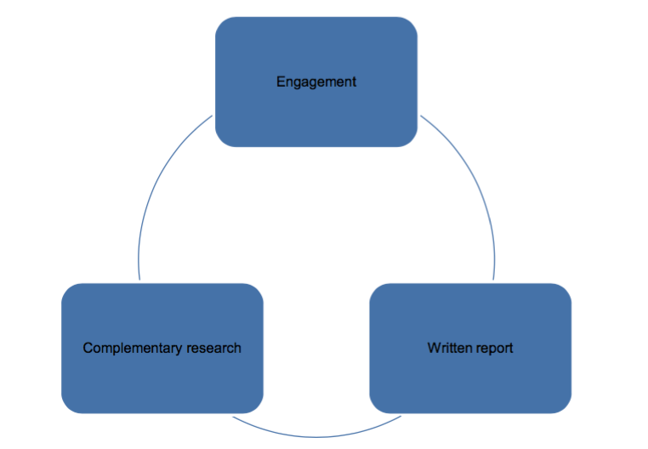

Engagement Activity Workflow

**COMPONENT 3: THE WRITTEN REPORT**

IT IS IMPORTANT TO REMEMBER THAT THE WRITTEN REPORT IS THE PIECE YOU WILL ACTUALLY SUBMIT AND THAT WILL BE ASSESSED.

As with many other larger writing projects (such as your EE), it is useful to formulate a question, tightly linked to the political issue, which you will then attempt to answer through your experiences and reading. Obviously, you are able to refine this question throughout the engagement activity process.

Your report must be no more than 2,000 words in length (but anything substantially below this is unlikely to meet the criteria for success).

Some points to consider:

* + 1. Your report must identify a political issue that you decided to explore through the engagement   
       and it must explain the reasons why you wanted to get engaged with this specific engagement and issue.
    2. If your engagement is large and multifaceted – perhaps it consists of several activities or you carried out several roles over the course of the engagement – then you must focus your report on aspects of the engagement that are most relevant for your treatment of the political issue.
    3. You should be careful that your report does not simply describe, at length, what you did during your engagement. Instead, the key aspect about the engagement in the report should be what it taught you about your selected political issue.
    4. You must synthesize your insights and evaluate the political issue from multiple perspectives (this could be Levels of Analysis or different perspectives of groups/individuals.

Structure and Word count:  
The IB does not require you to follow a set format or required structure for your report. However, it is important that you note the following from the Global Politics Subject Guide – ‘it is expected that the report is a structured piece of well-presented writing’.

As mentioned above, the word count is 2,000 words. However, the following are not included in the word count:

* + - 1. Acknowledgements
      2. Contents page
      3. Tables of statistical data
      4. Diagrams or figures
      5. Equations, formulae and calculations
      6. Citations (must, if used, be in the main body of the work) – you should note that a citation is a shorthand method of making a reference in the body of the report, which is then linked to the full reference in the bibliography
      7. References (if used, these must be in the footnotes/endnotes) – you should note that footnotes/endnotes must be used for references only. Definitions of terms and quotations, if used, must be in the body of the work and ARE included in the word count
      8. Bibliography
      9. Appendices

**ETHICAL GUIDELINES FOR THE POLITICAL ENGAGEMENT ACTIVITY**

This section is taken directly from the IB Subject Guide for Global Politics and applies to ALL students involved in a Political Engagement Activity.

Students must adhere to the following global politics course ethical guidelines when undertaking their engagement activity. They must show tack and sensitivity, respect confidentiality and acknowledge all sources used

* + - 1. Students and teachers must exercise judgment on which engagements may be suitable. This will vary from one location to another. Under no conditions must the safety of the student or any other participants in the activities be compromised
      2. Any data collected must be kept in a confidential and responsible manner and not divulged to any other person
      3. Any activity that involves deception, involuntary participation or invasion of privacy, including the inappropriate use of information and communication technology (ICT), email and the internet, must be avoided.
      4. Young children should not be used as participants. Interviews involving children need the written consent of parents/guardians and students must ensure parents are fully informed about the nature of the activity. Where an activity is conducted with children in a school, the consent of teachers must also be obtained
      5. Students must avoid conducting research with any adult who is not in a fit state of mind and cannot respond freely and independently
      6. Any activity which creates stress, pain or discomfort for participants must not be permitted
      7. Participants and interviewees must be debriefed and given the right to withdraw their own personal data and responses. Anonymity for each participant must be guaranteed, expect for interviewees in an elected or appointed government role or formal non-state actor role
      8. Acknowledging that some interviewees may not be in a position to or may not choose to respond to questions freely and independently, students should, when suspecting this to be the case,   
         complement their primary research with other opinions
      9. Using relatives as a source in the engagement activity is not advisable, but if students should choose to do so, this must be declared
      10. Teachers and students should exercise sensitivity to local and international cultures
      11. Students must not falsify or make up data

**STUDENTS FOUND TO HAVE CARRIED OUT UNETHICAL WORK WILL BE AWARDED NO MARKS FOR THE POLITICAL ENGAGEMENT ACTIVITY COMPONENT OF THE COURSE.**

**Timeline for Engagement Activity Completion.**

|  |  |
| --- | --- |
| **Date** | **Event** |
| October 31st (B)/November 1st (A) | Fill in proposal form and submit to me for approval.  Turn in a rough draft timeline of when your engagement components will be completed along with your proposal (Must be completed by December 16th or recieve prior approval to complete at a later date |
| December 9th (A)/December 10th (B) | ***Rough Draft***: **Part A** (Identification/Justification) and **Part B** (Explanation) |
| November 1st – December 16th | Complete engagement activities and research. |
| December 16th (A)/December 17th (B) | ***Annotated Bibliography*** with supplementary research due (Should have 3-5 sources) |
| Week of January 6th and January 13th | Revisions-Part A and Part B  Work on Drafts for Part 3(Analysis) / Peer edit and correct |
| Week of January 20th and January 27th | Revisions Part 3(analysis) and work on part 4 (Synthesis and evaluation; peer edit and correct |
| Week of February 3rd | Students should compile complete first draft (including appendecies, bibliography etc...) and turn in for teacher feedback by end of week |
| Week of February 17th | Final Drafts due to teacher/IB Coordinator (1 paper and 1 electronic copy) |

**THE ASSESSMENT CRITERIA FOR THE EA WRITTEN REPORT**

This is the assessment criteria that your teacher will use to mark the written report so it is important that you familiarize yourself with it. If you do not understand anything then talk to your teacher to clarify any misunderstanding. You will be assessed according to four different criteria. The questions in red are the questions the person reading your report will be trying to answer and the level descriptors will guide them in allocating marks accordingly.

**CRITERION A: IDENTIFICATION OF ISSUE AND JUSTIFICATION (4 MARKS)**

* 1. Is the political issue explored through the engagement identified?
  2. Is there a clear explanation of why this particular engagement and political issue are of interest to the student?
  3. Is 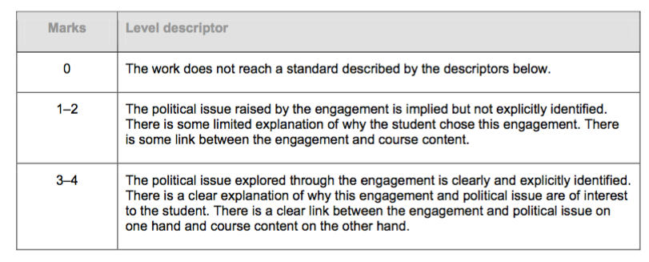there a clear link between the engagement and political issue on one hand and course content on the other hand?

**CRITERION B: EXPLANATION OF THE ENGAGEMENT (4 MARKS)**

* 1. Is the description of the engagement and of what the student actually did clear and relevant for their chosen political issue?
  2. Is there a clear explanation of the ways in which the student’s experiences informed his or her understanding of the political issue?   
     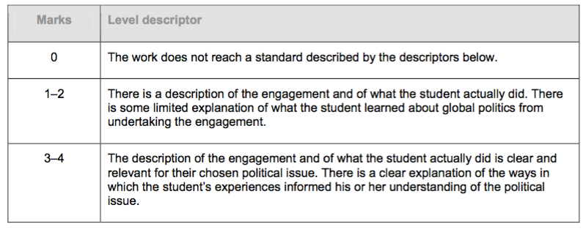

**CRITERION C: ANALYSIS OF ISSUE (6 MARKS)**

* 1. To what extent does the student analyse the political issue?
  2. To what extent does the student justify his or her main points?   
     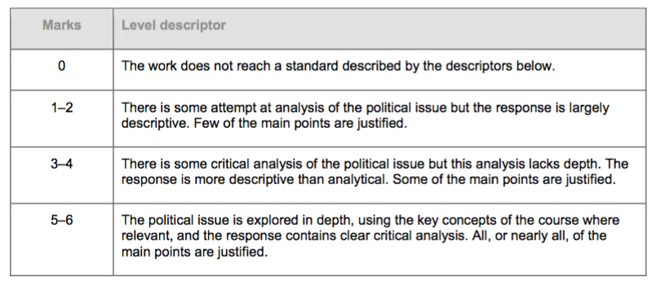

**CRITERION D: SYNTHESIS AND EVALUATION (6 MARKS)**

* 1. To what extent does the student synthesize his or her experiences and research in the discussion of the political issue?
  2. To what extent does the student show evidence of evaluation, underpinned by his or her experiences and adequate research, to allow multiple perspectives on the political issue?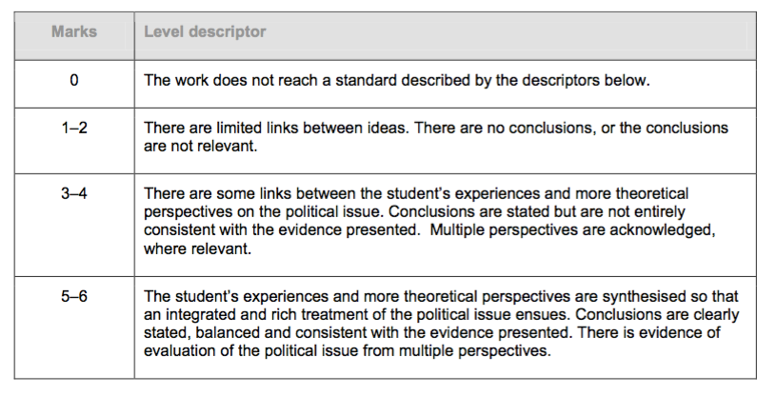



**CRITERION A: IDENTIFICATION OF ISSUE AND JUSTIFICATION (4 MARKS)**

This assessment criterion looks at the degree to which the student can explain why they participated in the activity in the first place. **The key here is to explain WHY the activity helped them to explore the political issue that they chose.**

**NOTE: There is no need for students to explain how the activity helped them to build other skills such as teamwork or leadership skills — There is no reward on the markscheme for doing anything like this.**

**CRITERION B: EXPLANATION OF THE ENGAGEMENT (4 MARKS)**

This assessment criterion focuses on how well the student identified and explained their engagements. It seeks to explain the reasons why the activity was chosen, including why it was suitable for exploring and analyzing. Students will also need to explain the ways in which the activity has helped the student understand key concepts and learning outcomes that relate to the chosen political issue.

**CRITERION C: ANALYSIS OF ISSUE (6 MARKS)**

This assessment criterion focuses on the analysis of the political issue drawing on everything that you’ve learned in Global Politics. Within this section the student will focus on answering the question, **“To what extent.”**

The student will need to support all of their claims that they make in the analysis. They will answer the question, **“how do you use evidence to support your claims?”**

They will demonstrate:

* + - 1. logical and organized thinking
      2. Examples from coursework and experience
      3. Using examples that were researched in the EA

**CRITERION D: SYNTHESIS AND EVALUATION (6 MARKS)**

This assessment criterion focuses on the evaluation of the student experiences using theoretical perspectives to generate a new understanding of the issue. They will use a diverse set of evidence and counterclaims to the arguments.

RESOURCES: IGO/NGO and Political Organizations in the St. Louis Area

1. **International Institute of St. Louis**: Assists foreign born individuals in resettlement, buisnesss startup and community engagement
2. **Immigrant Service Provider Network**: Aims to support the foreign born and thier families by coordinating efforts to increase the capacityof community resources, advocate for inclusive policy and services, and educate residents and providers in the St. Louis region.
3. **Casa de Salud**: Delivers basic, high quality clinical and mental health services for uninsured and underinsured patients, focusing on new immigrants and refugees.
4. **Parkway Area Adult Education and Literacy:** Offers free ESL classes to adults throughout St. Louis county
5. **St Louis Regional Chamber**: Enhances the business climate and livability of St. Louis by promoting economic growth
6. **US Citizenship and Immigration Services Office**: Field offices located accross the St. Louis region
7. **St. Frances Communities Services:** Offers support and strengthens immigrant families from throughout the region, while also addressing need in the Bevo neighborhood.
8. **American Red Cross of Eastern Missouri**: Provides relief to victims of disaster, blood to hospital patients, health and safety traiing to the public and emergency social services to U.S. military families.
9. **United Way of Greater St. Louis**: A local organization that offers a variety of services in community building and resource access.
10. **Allaince for Healthy Communities**: Aims to engage the community to reduce youth substance abuse and risks of suicide by raising awareness and changing community norms.
11. **American Civil Liberties Union of Missouri**: Defends civil liberties and the principles of equality and justice through Missouri, through litigation, legislative and public education programs.
12. **American Association of University Women**: Aims to advance equity for women and girls through advocacy, education, philanthropy and research
13. **Better Together STL**: Supports the St. Louis region by acting as a catalyst for the removal of governmental, economic and racial barriers to the region’s growth and prosperity for all of our citizens by promoting unity, trust, efficiency and accountability
14. **CAPCR (Coalition Against Police Crimes and Repression):** Aims to end police crimes and abuse; end the criminilzation of a generation and expose the prison industrial comple
15. **Forward Through Ferguson**: Aims to make St. Louis a more racially equitable region—a state in which outcomes are no longer predictable by race.
16. **Girls in the Know**: Aims to educate and empower girls, together with those who love them, by providing tools to establish a strong sense of self.
17. **Gateway Housing First/Places for People**: Provides safe, affordable, supported housing for individuals with a wide range of disabilities, complex disorders and life situations who struggle to secure or maintain housing
18. **Hands Up United**: Collective of politically engaged minds building towards the liberation of oppressed Black, Brown and poor people through education, art, civil disobedience, advocacy and agriculture
19. **Human Rights Campaign-St Louis**: To inspire and engage individuals and communities, HRC strives to end discrimination against LGBTQ people and realize a world that achieves fundamental fairness and equality for all.
20. **Immigrant and Refugee Women’s Program**: To increase the Independence and reduce the isolation of immigrant and refugee women by teaching them basic English and practical living skills in the security of their own homes.
21. **Missouri Healthcare for ALL**: To create awareness and change so that every Missourian deserves access to quality, affordable healthcare, no matter where they live or how much money they make.
22. **MoveOn.org**: To envision a world marked by equality, sustainability, justice, and love; whether its supporting a candidate, fighting to pass legislation or working to change our culture.
23. **National Women’s Political Caucus**: To identify, support, recruit and train women candidates for elected and appointed office under an umbrella of pro-choice, multi-partisan and grassroots organizaiton

**Course Content**

It is a good idea to base your question around content which is covered in the course. Below you will find the full course outline.

|  |  |  |
| --- | --- | --- |
| **Unit 1: Power, Sovereignty and International Relations** | | |
| *Key Concepts- Power, Sovereignty, Legitimacy, Interdependence* | | |
| **Learning outcome** | **Prescribed Content** | **Possible Examples** |
| Nature of power | Definitions and Theories of power | Joseph A Dahl  John Mearsheimer  Joseph Nye  Antonio Gramsci  Stephen Lukes |
| Types of Power | Hard versus soft; economic, military, social, cultural; individual versus collective; unilateral versus multilateral |
| Operation of state power in global politics | The evolving nature of state sovereignty | Terminology (state, nation, nation-state, stateless nation)  Westphalian conception of state sovereignty  Present day sources of state sovereignty, e.g. possession and use of force, international law and norms, recognition by other states due to economic and balance of power considerations, consent (or lack thereof) of the governed through political participation  Present-day challenges to state sovereignty e.g. globalization, supranationality, humanitarian intervention, indigenous rights. |
| Legitimacy of state power | Democratic states, e.g. unitary states, federal states  Authoritarian States  Fragile/Failed States |
| Function and impact of international organisations and non-state actors in global politics | The United Nations (UN) | The UN  The UN Charter  UN principal organs |
| Intergovernmental organisations (IGOs) | WTO, IMF, EU, ASEAN, other various IGOs  Independent Investigations |
| Non-governmental organisations (NGOs) | NGOs, eg International Red Cross and Red Crescent Movement, Amnesty International (AI), Human Rights Watch (HRW), Greenpeace  Independent Investigations |
| Social movements, resistance movements and violent protest | Social movements- Civil Rights in the US and Occupy Wallstreet  Resistance movements- Arab spring  Violent protest movements- Ukrainian revolution |
| Political Parties | USA’s Republican and Democratic parties, Germany’s Christian Democratic Union (CDU) and Social Democratic Party (SPD), Communist Party of China (CPC) |
| Informal Forums | G20, G7 |
| Legitimacy of non-state actors | Ways in which non-state actors legitimise their authority |
| Nature and extent of interactions in global politics | Global Governance | UN Security Council resolutions, climate change agenda |
| Cooperation: Treaties, collective security, strategic alliacnes, economic cooperation, informal cooperation | Treaties-  Economic cooperation- TPP  Collective secutiry- NATO  COP21 |
| Conflict: Interstate war, intrastate was, terrorism, strikes, demonstrations | Interstate war, eg Iraq, Afghanistan, Sudan, South Sudan  Intrastate war, eg Syria, Ukraine, Democratic Republic of the Congo (DRC), Central African Republic  Terrorism, eg Islamic State of Iraq and Syria (ISIS), al-Quaeda, Boko Haram attacks, 9/11  Strikes and demonstrations: local examples |
| **Unit 2: Human Rights** | | |
| *Key Concepts- Human Rights, Justice, liberty, Equality* | | |
| **Learning outcome** | **Prescribed Content** | **Some of what we looked at** |
| Nature and evolution of human rights | Definitions of human rights | Notions such as inalienability, universality, indivisibility, equality, justice, liberty |
| The UN’s Universal Declaration of Human Rights (1948) | |
| Developments in human rights over time and space | Human rights milestones, eg civil and political rights, economic, social and cultural rights, gender rights, children’s rights, indigenous people’s rights, refugee rights  Internationalization of human rights, eg universal jurisdiction, international humanitarian law |
| Codification, protection and monitoring of human rights | Human rights laws and treaties | Role of custom  Human rights in constitutions, eg South Africa, Brazil  International examples, eg International Covenant on Civil and Political Rights (ICCPR) and International Covenant on Economic, Social and Cultural Rights (ICESCR), Convention on the Protection of the Rights of All Migrant Workers and Members of Their Families, Rome Statute |
| Protection and enforcement of human rights at different levels | National courts and police, International Court of Justice (ICJ), International Criminal Court (ICC), Inter-American Commission on Human Rights (IACHR), Cambodia Tribunal |
| Monitoring human rights agreements | Human Rights Watch (HRW), Amnesty International (AI), |
| Practice of human rights | Claims on human rights | Labour rights, indigenous land claims, movements for gender equality, debates about same-sex marriage |
| Violations of human rights | Child soldiers, human trafficking, forced labour, forced relocation, denial of prisoners of war rights, violations of freedom of speech, violations in the name of prevention of terrorism, gender discrimination |
| Debates surrounding human rights: differing interpretations of justice, liberty and equality | Individual Rights vs collective rights | Individual Debates and work |
| Universal rights cs. Cultural relativism | Individual Debates and work |
| Politicisation of human rights | Individual Debates and work |
| **Unit 3: Development** | | |
| *Key Concepts- Development, Globalisation, Inequality, Sustainability* | | |
| **Learning outcome** | **Prescribed Content** | **Some of what we looked at** |
| Contested meanings of development | Different definitions of development, including sustainable development and well-being | Economic growth, fairer income distribution, reduction in poverty, meeting basic needs, improved capabilities, achievement of political and social freedoms, well- functioning institutions, lifestyles that respect the ecological constraints of the environment |
| Measuring Development | Gross national product (GNP), Human Development Index (HDI), Genuine progress indicator (GPI), inclusive wealth index (IWI), Happy Planet Index (also HPI), corruption indices, trust indices |
| Factors that may promote or inhibit development | Political factors | Ideologies, history of and persistence of conflict, stability, accountability, transparency, legal frameworks, political consequences of different development paths, decisions about the allocation of aid, political culture, culture of bureaucracy, vested interests |
| Economic factors | Access to resources, increasing resource constraints, infrastructure, debt, access to capital and credit, aid, trade, foreign direct investment (FDI), income distribution, informal economy, vested interests |
| Social factors | Values, cultures, traditions, gender relations, migration |
| Institutional factors | The UN, IMF, World Bank, WTO, partnerships between developing countries, efficacy of national and local institutions |
| Environmental factors | Geography, resource endowment, consequences of climate change on people and communities’ lives  Refer back to COP21 |
| Pathways towards development | Models of Development | Neoliberal theories (eg Washington Consensus), state capitalism (eg China, Russia), capability theories (eg Sen, Nussbaum) |
| Approaches for developing the economy | Trade liberalization, export orientation, commodity-led growth, tourism, entrepreneurship, knowledge economy, circular economy, complementary currencies |
| Approaches for developing society | Concern for citizenship skills and engagement, improving education and healthcare, changing roles of women, more ecological living, indigenous revitalization movements |
| Debates surrounding development: challenges of globalisation, inequality and sustainable | Globalisation, inequality and sustainable | Facts about development of standard of living and assessment of realization of human rights, well-being and opportunity for different groups of people within and between societies  Environmental impacts of globalization  Various perspectives, eg North, South, rising powers |
| **Unit 4: Peace and conflict** | | |
| *Key Concepts-Peace, conflict, violence, non-violence* | | |
| **Learning outcome** | **Prescribed Content** | **Some of what we looked at** |
| Contested meanings of peace, conflict and violence | Different definitions of peace, conflict and violence, including positive peace and structural violence | 3 Definitions of Peace (Equilibrium, Negative, and Positive Peace)  Global Peace Index (GPI)  Balance of Power Theory  Security Dilemma  Ways to deal with an aggressor: Balancing, Bandwagoning Buckpassing, Blood-letting  Levels of Conflict Intensity  Galtung’s Violence Triangle (Direct, Cultural, Structural Violence) |
| Types of conflict | Territorial Conflict (South China Sea Dispute)  Non-violent Conflict (Iran Nuclear Deal, Scottish Independence)  Violent Conflict (Syria)  Identity Conflict (Rohingya Muslim) |
| Justifications of violence, including just war theory | Justification for Violence  UDHR vs UN Charter  Humanitarian Intervention  Rwandan Genocide |
| Causes and parties to conflict | Causes of conflict |  |
| Parties to conflict |
| Evolution of conflict | Manifestations of conflict, including non-violence |
| Conflict dynamics |
| Third-party involvement in conflict, including humanitarian intervention |
| Conflict resolution and post-conflict transformation | Peacemaking, including negotiations and treaties |
| Peace building, including reconciliation and work of justice institutions |

**Key Concepts**

To ensure that you have a strong engagement activity, you need to build your political issue around one of the key concepts covered in the GloPo course. Below you will find the key concepts.

|  |  |
| --- | --- |
| **Concept** | **Explanation** |
| Power | Power is a central concept in the study of global politics and a key focus of the course. Power can be seen as ability to effect change and, rather than being viewed as a unitary or independent force, is as an aspect of relations among people functioning within a social organization. Contested relationships between people and groups of people dominate politics, particularly in this era of increased globalization, and so understanding the dynamics of power plays a prominent role in understanding global politics. |
| Sovereignty | Sovereignty characterizes a state’s independence, its control over territory and its ability to govern itself. How states use their sovereign power is at the heart of many important issues in global politics. Some theorists argue that sovereign power is increasingly being eroded by aspects of globalization such as global communication and trade, which states cannot always fully control. Others argue that sovereign states exercise a great deal of power when acting in their national interest and that this is unlikely to change. |
| Legitimacy | Legitimacy refers to an actor or an action being commonly considered acceptable and provides the fundamental basis or rationale for all forms of governance and other ways of exercising power over others. The most accepted contemporary source of legitimacy in a state is some form of democracy or constitutionalism whereby the governed have a defined and periodical opportunity to choose who they wish to exercise power over them. Other sources of legitimacy are suggested in states in which such an opportunity does not exist. Within any proposed overall framework of legitimacy, individual actions by a state can be considered more or less legitimate. Other actors of global politics and their actions can also be evaluated from the perspective of legitimacy. |
| Interdependence | In global politics, the concept of interdependence most often refers to the mutual reliance between and among groups, organizations, geographic areas and/or states for access to resources that sustain living arrangements. Often, this mutual reliance is economic (such as trade), but can also have a security dimension (such as defence arrangements) and, increasingly, a sustainability dimension (such as environmental treaties). Globalization has increased interdependence, while often changing the relationships of power among the various actors engaged in global politics. |
| Human rights | Human rights are basic claims and entitlements that, many argue, one should be able to exercise simply by virtue of being a human being. Many contemporary thinkers argue they are essential for living a life of dignity, are inalienable, and should be accepted as universal. The Universal Declaration of Human Rights adopted by the UN in 1948 is recognized as the beginning of the formal discussion of human rights around the world. Critics argue that human rights are a Western, or at least culturally relative, concept. |
| Justice | There are a number of different interpretations of the concept of justice. It is often closely associated with the idea of fairness and with individuals getting what they deserve, although what is meant by deserve is also contested. One avenue is to approach justice through the idea of rights, and what individuals can legitimately expect of one another or of their government. Some theorists also argue that equality not only in the institutions and procedures of a society but also in capabilities or well-being outcomes is required for justice to be realized. |
| Liberty | The concept of liberty refers to having freedom and autonomy. It is often divided into positive and negative liberty, with *negative liberty* defined as individuals having the freedom from external coercion and *positive liberty* defined as individuals having the autonomy to carry out their own rational will. Some scholars reject this distinction and argue that in practice, one form of liberty cannot exist without the other. It is also questioned if such an understanding of liberty is sufficient for an interdependent world, in which the seeming freedom and autonomy of some may depend on lack of some forms of liberty for others. Hence, debates on equality inform our understanding of liberty as well. |
| Equality | Egalitarian theories are based on a concept of equality that all people, or groups of people, are seen as having the same intrinsic value. Equality is therefore closely linked to justice and fairness, as egalitarians argue that justice can only exist if there is equality. Increasingly, with growing polarization within societies, equality is also linked to liberty, as different people have differing possibilities to be free and autonomous. |
| Development | Development is a sustained increase in the standard of living and well-being of a level of social organization. Many consider it to involve increased income; better access to basic goods and services; improvements in education, health care and public health; well-functioning institutions; decreased inequality; reduced poverty and unemployment; and more sustainable production and consumption patterns. The focus of development debates in contemporary global politics is on issues faced by developing countries, and on the imperative of shifting the focus from modernization (seen as Westernization). However, all societies and communities face questions about how to best promote well-being and reduce ill-being. |
| Globalization | Globalization is a process by which the world’s local, national and regional economies, societies and cultures are becoming increasingly integrated and connected. The term refers to the reduction of barriers and borders, as people, goods, services and ideas flow more freely between different parts of the world. Globalization is a process that has been taking place for centuries but the pace has quickened in recent decades, facilitated by developments in transportation and communication technology, and powered by cheap energy. It is now widely acknowledged that globalization has both benefits and drawbacks and that its benefits are not evenly distributed. |
| Inequality | Inequality refers to a state of affairs where equality between people or groups of people is not realized and the consequent potential compromises of justice and liberty. Inequality often manifests itself through unequal access to resources that are needed to sustain life and develop individuals and communities. Consequently, the concept is closely connected to discussions of power and of who holds the rights to these resources and their proceeds. Inequality can be examined both as a phenomenon within and between societies. |
| Sustainability | Definitions of sustainability begin with the idea that development should meet the needs of the present without compromising the ability of future generations to meet their needs. Sustainability today has three fields of debate— environmental, sociopolitical and economic. In global politics, mechanisms and incentives required for political institutions, economic actors and individuals to take a longer term and more inclusive well-being perspective in their decision-making are particularly important. |
| Peace | Peace is often defined as both the absence of conflict and violence as well as a state of harmonious relations. Many also refer to peace as a personal state of non-conflict, particularly with oneself and with one’s relationship to others. Peace is the ultimate goal of many organizations that monitor and regulate social relationships. |
| Conflict | Conflict is the dynamic process of actual or perceived opposition between individuals or groups. This could be opposition over positions, interests or values. Most theorists would distinguish between non-violent and violent conflict. In this distinction, non-violent conflict can be a useful mechanism for social change and transformation, while violent conflict is harmful and requires conflict resolution. |
| Violence | Violence is often defined as physical or psychological force afflicted upon another being. In the context of global politics, it could be seen as anything someone does that prevents others from reaching their full potential. This broader definition would encompass unequal distribution of power that excludes entire groups from accessing resources essential for improved living standards or well-being, and discriminatory practices that exclude entire groups of people from accessing certain resources. |
| Non-violence | Non-violence is the practice of advocating one’s own or others’ rights without physically harming the opponent. It often involves actively opposing the system that is deemed to be unjust, through for example boycotts, demonstrations and civil disobedience. Theorists argue that non-violence can often draw attention to a conflict situation and that it could provide a fertile basis for post-conflict transformation. |

**Levels of Analysis**

In your Engagement Activity, it is useful to analyze the political issue from different Levels of Analysis which are listed below.

|  |  |
| --- | --- |
| **Level of Analysis** | **Explanation** |
| Global | In the context of the global politics course, the term *global* refers to events and trends that have far-reaching and long-term impact across the world, cutting across national identities and interests. Examples include, but are not limited to, climate change, migration, terrorism, epidemics, etc. |
| International | In the context of the global politics course, the term *international* refers to events and trends that have a narrower impact than global events and trends, but nonetheless have implications for several countries. Examples include, but are not limited to, the operation of various international organizations, non-governmental organizations (NGOs), multinational corporations (MNCs), international law, etc. |
| Regional | In the context of the global politics course, the term *regional* refers to events and trends that have implications limited to a particular geographic region, such as the Middle East, Latin America, Eastern Europe, Western Europe, etc. Examples include, but are not limited to, the operation of the European Union (EU), the North Atlantic Treaty Organization (NATO), the Association of Southeast Asian Nations (ASEAN), The Arab League, etc. |
| National | In the context of the global politics course, the term *national* refers to events and trends that have a limited impact within the geographical boundaries of a particular country. Examples include, but are not limited to, economic crises or economic change in a particular state, political and legal reforms in a particular state, changes in the governance of a particular state, etc. |
| Local | In the context of the global politics course, the term *local* is used to refer to the geographic area in which social organization is created and in which culture is transmitted from one generation to the next. Local is defined by its inhabitants and their practices, and so can represent a geographic space as small as a gated community or as large as a city or region. |
| Community | The idea of community is one of the most debated concepts in the social sciences. Communities were once thought of as geographically based groups of people with similar interests, mutual support and cultural traits. The most commonly held view was that communities must include not only spatial and ecological definitions, but institutional and emotional ones. Recently, however, processes of globalization have led social scientists to rethink standard definitions. Advances in communication technologies allow similar interests to be nurtured beyond physical boundaries, and the definition of community has become intertwined with debates about globalization and the role and place of people within it. |

**Example of Completed Engagement Activity**

(Grades and comments at the end)

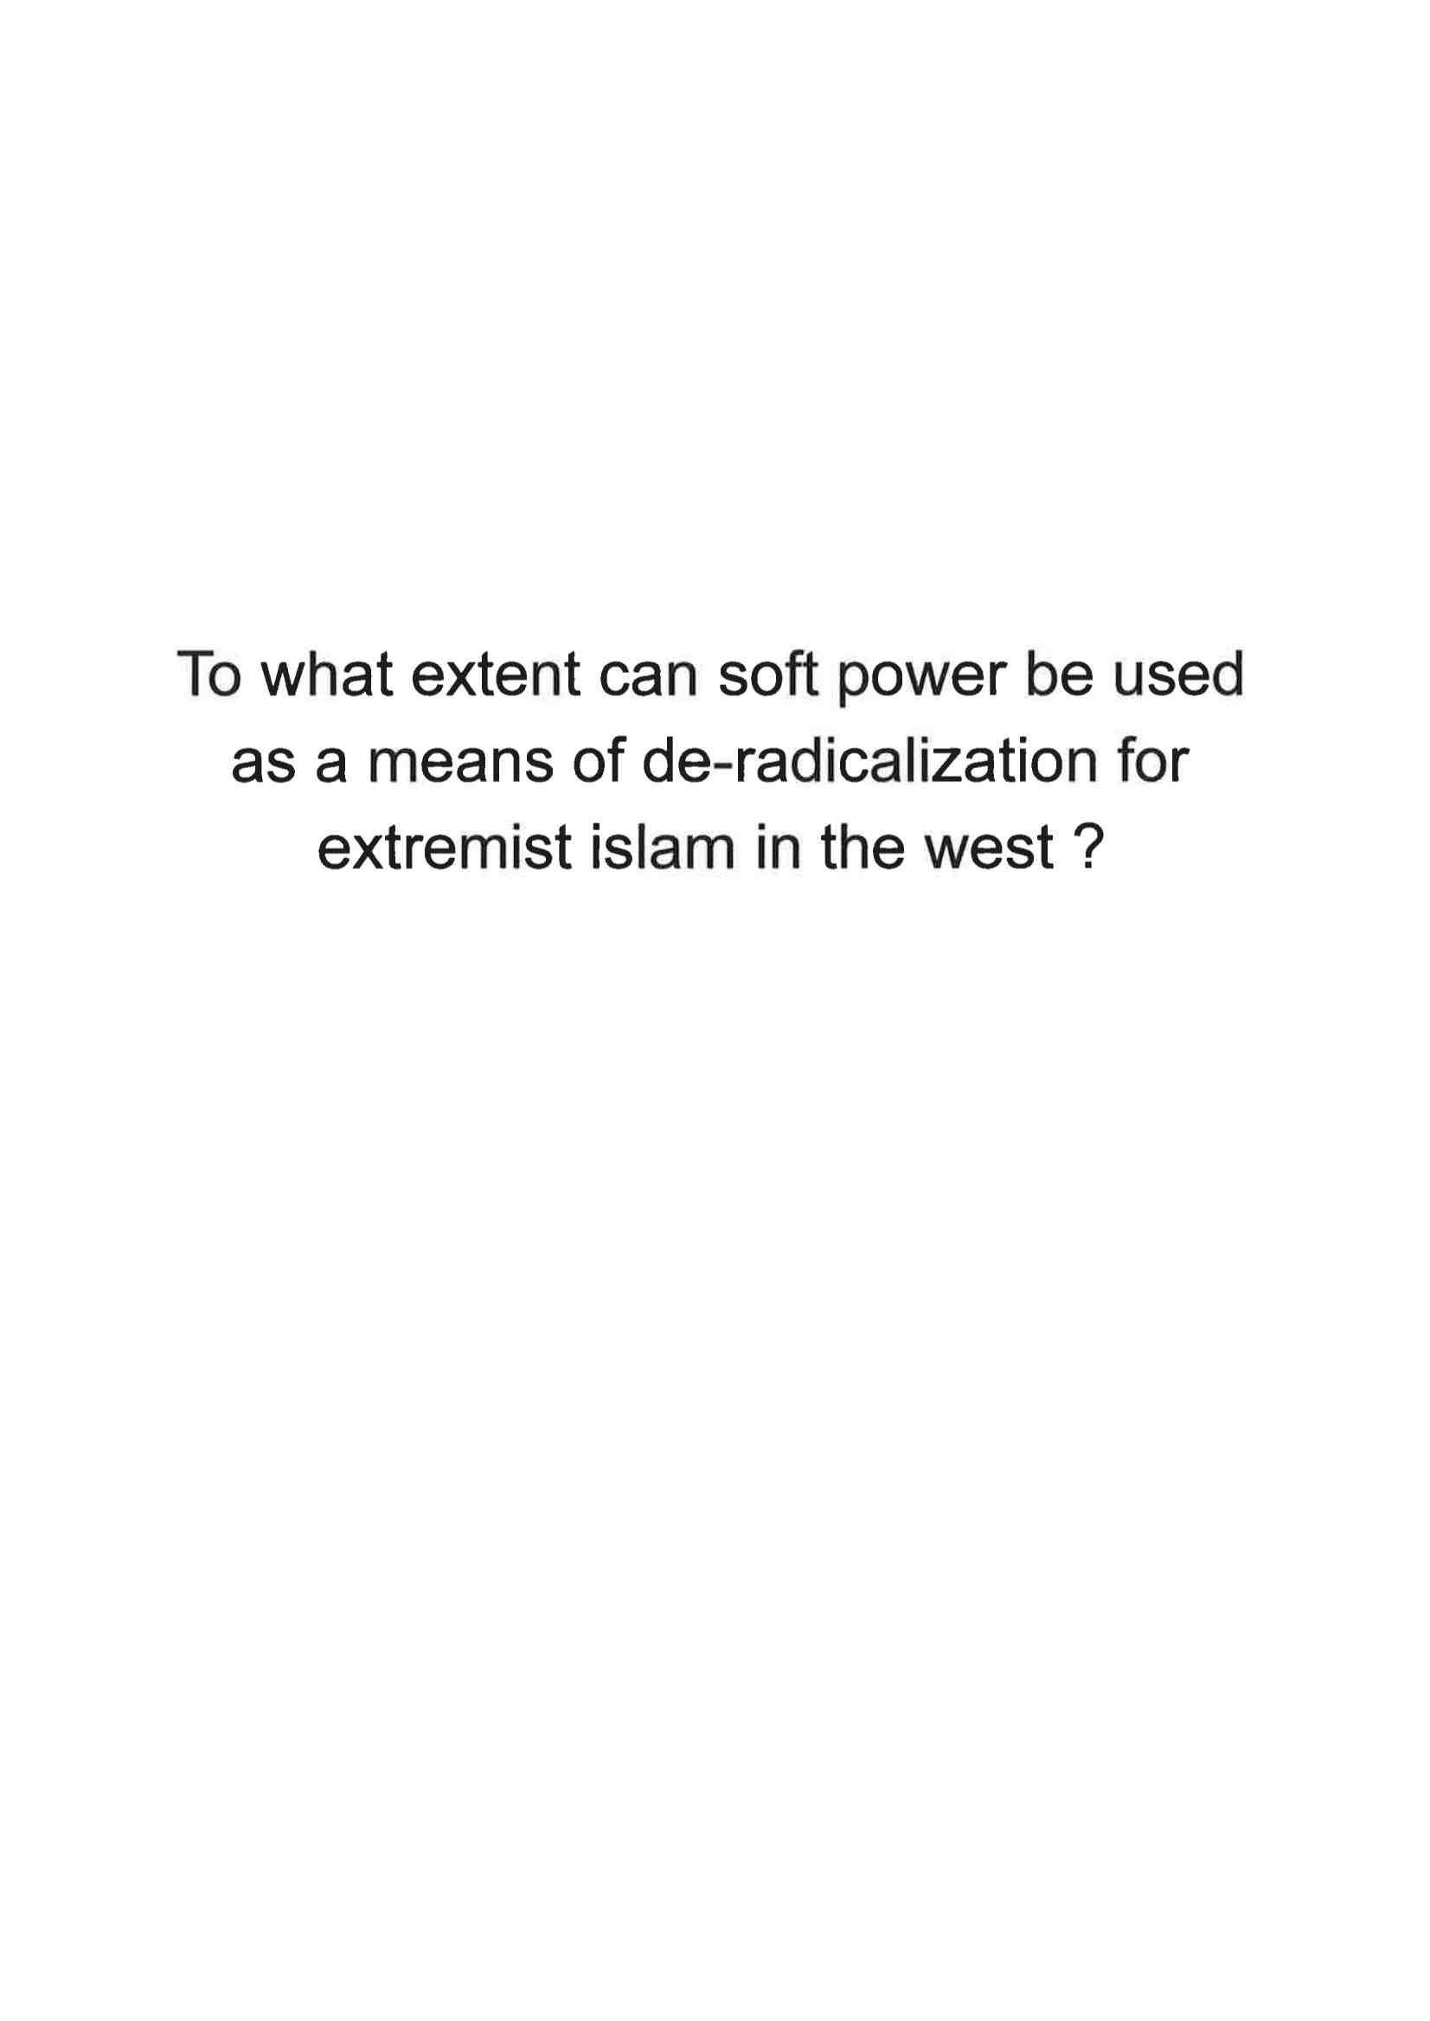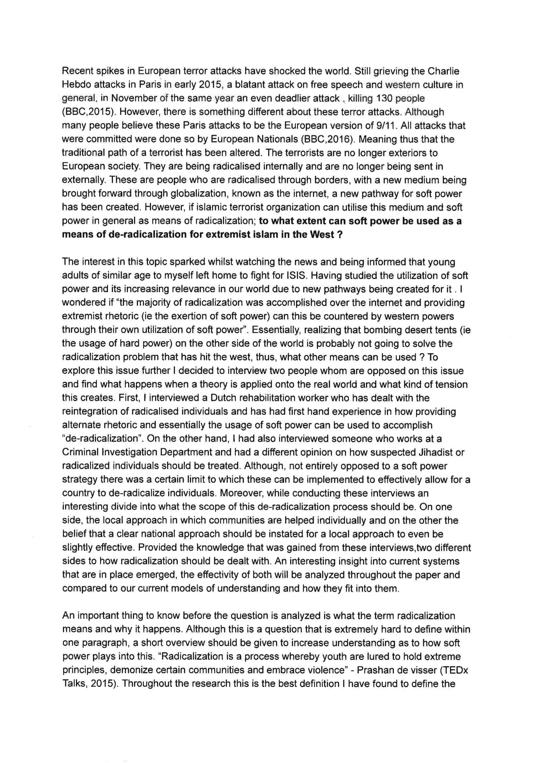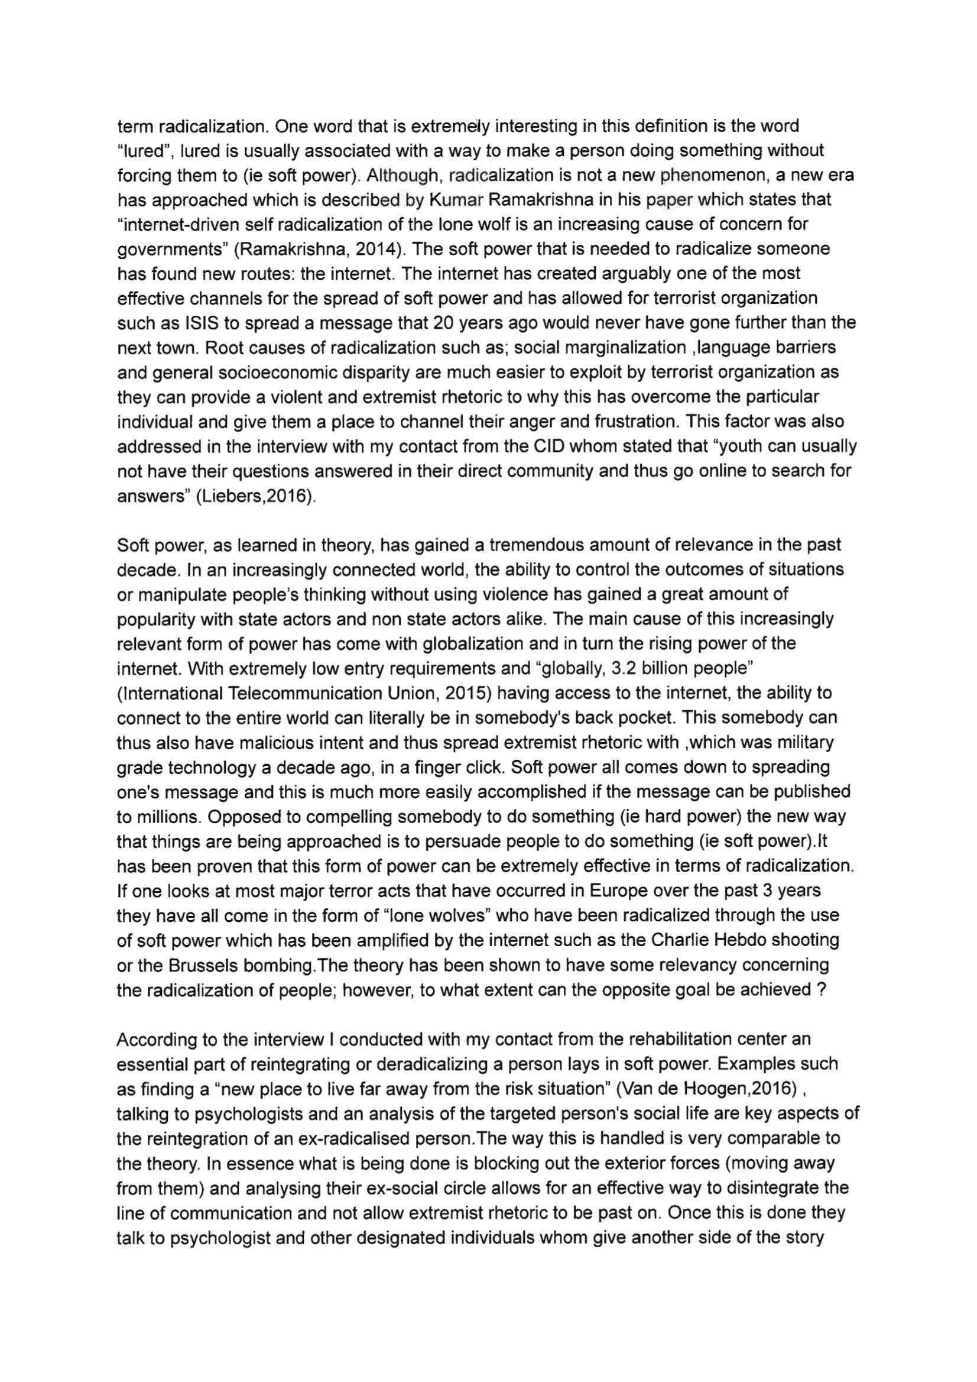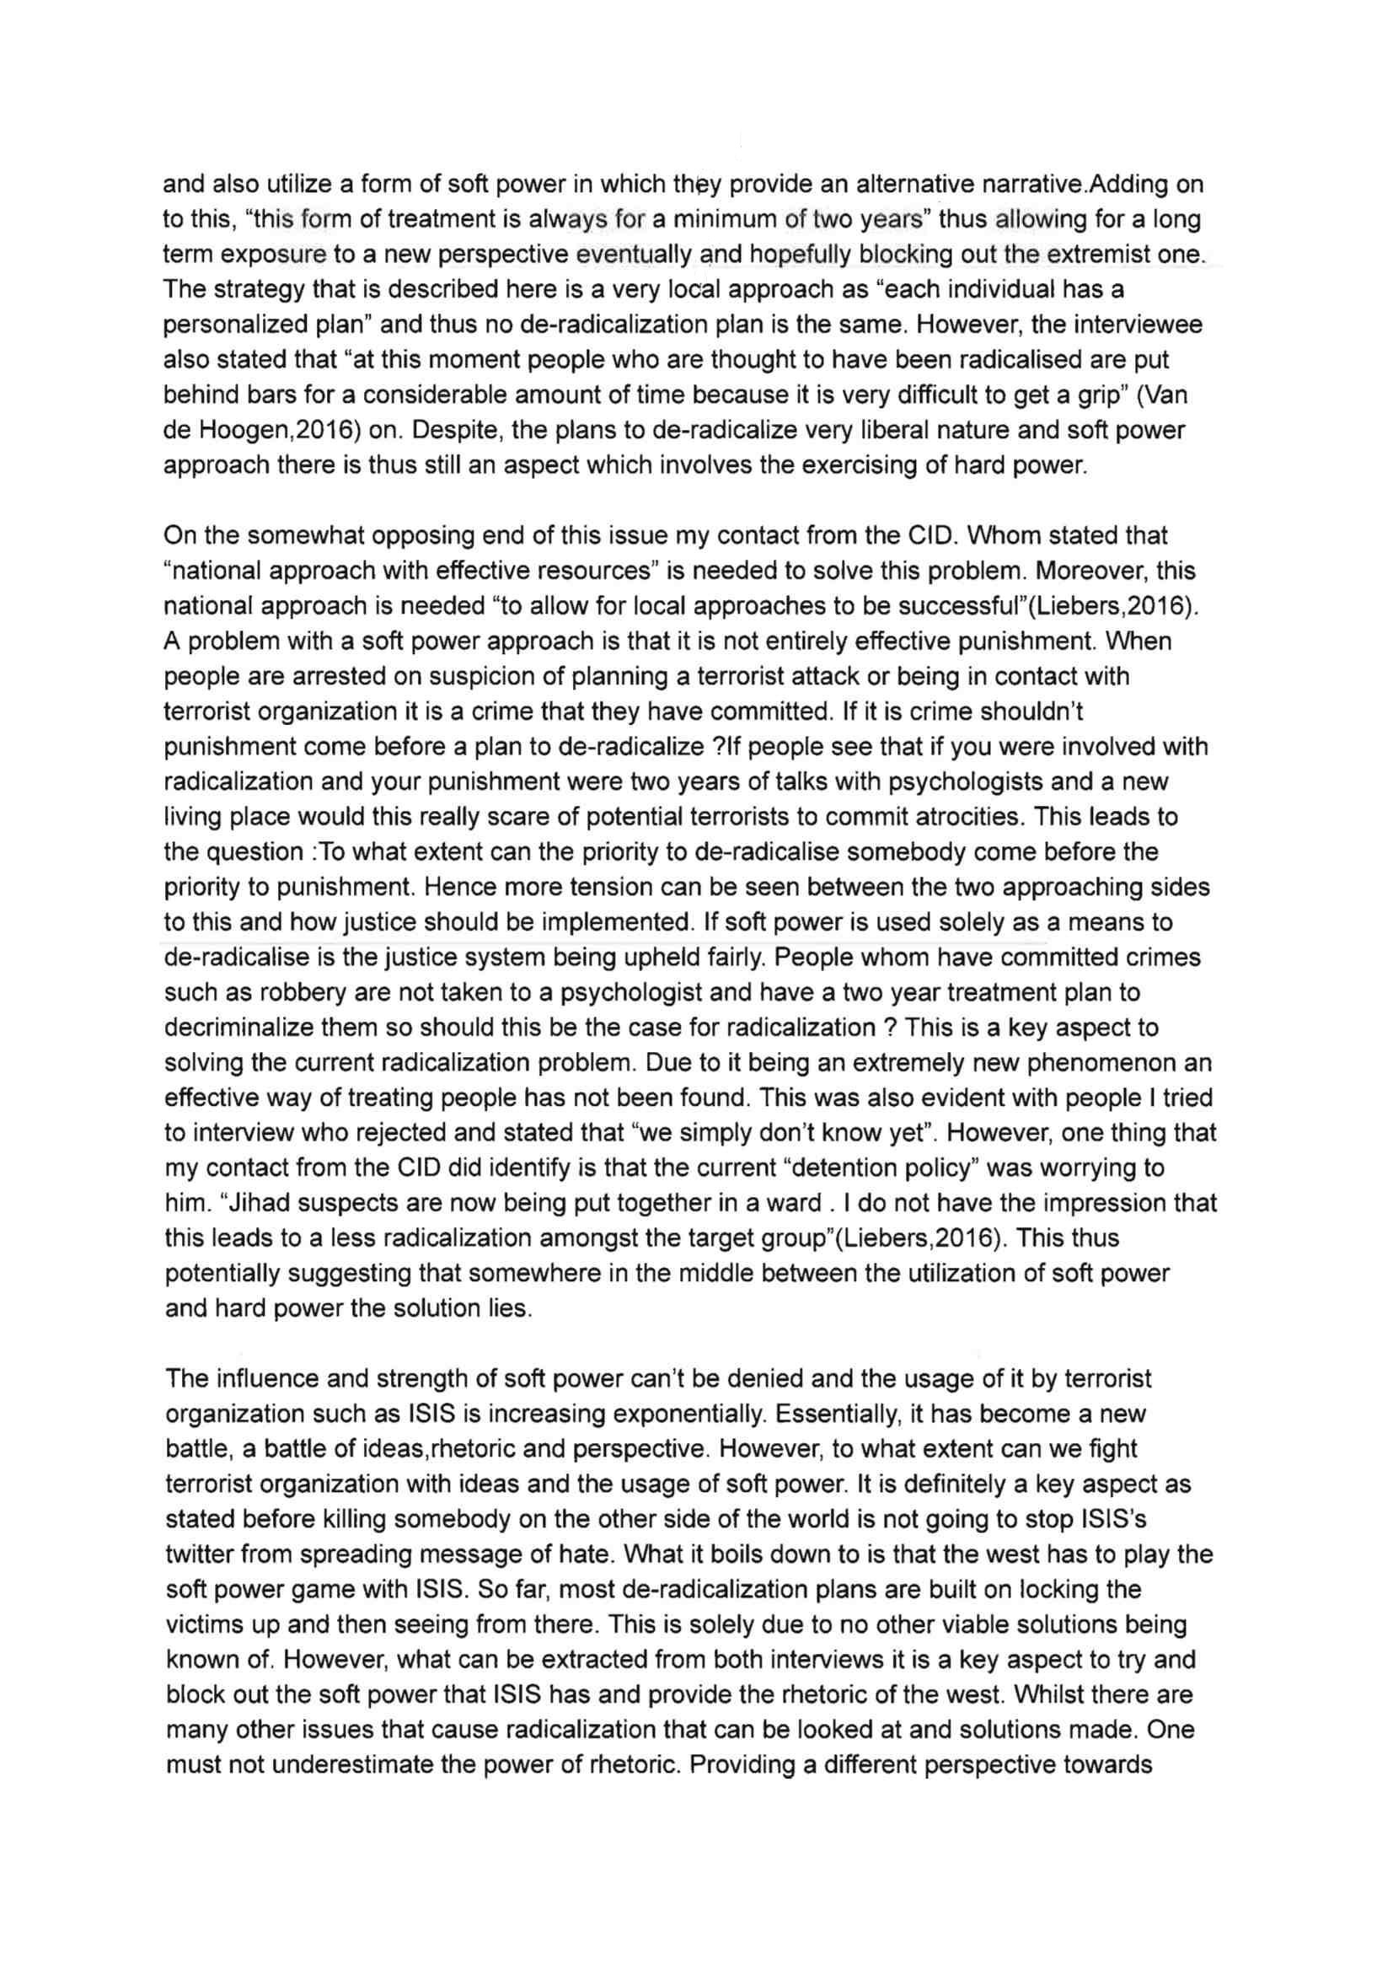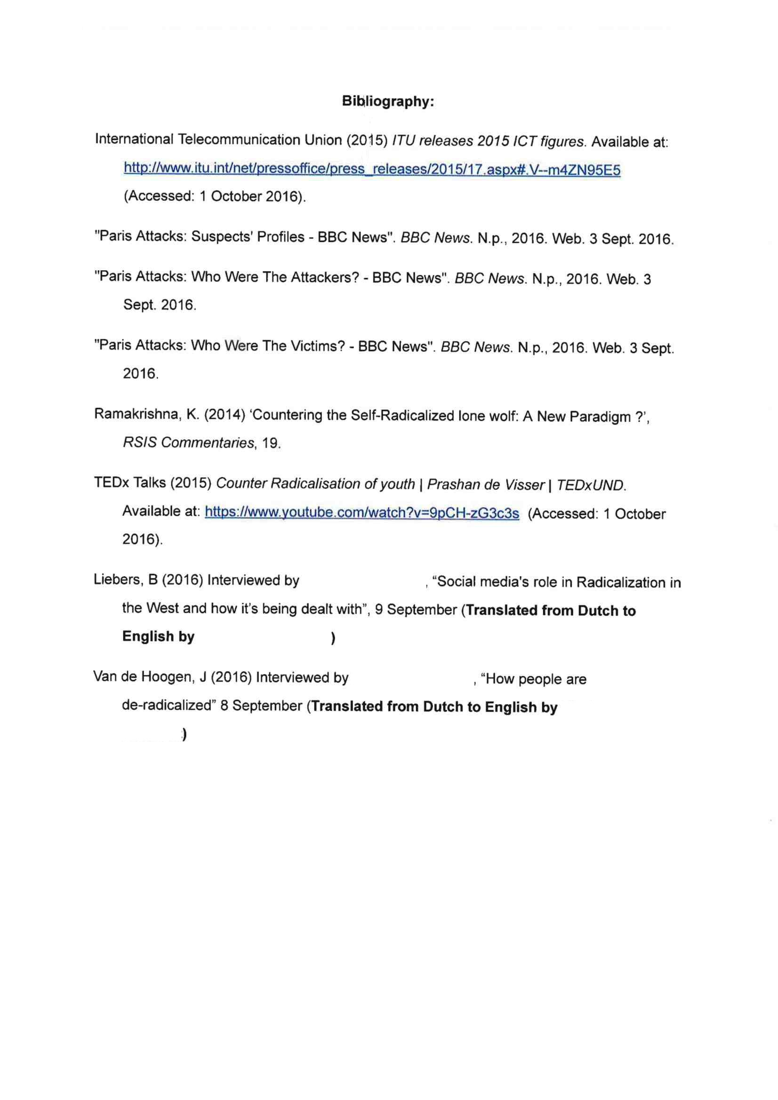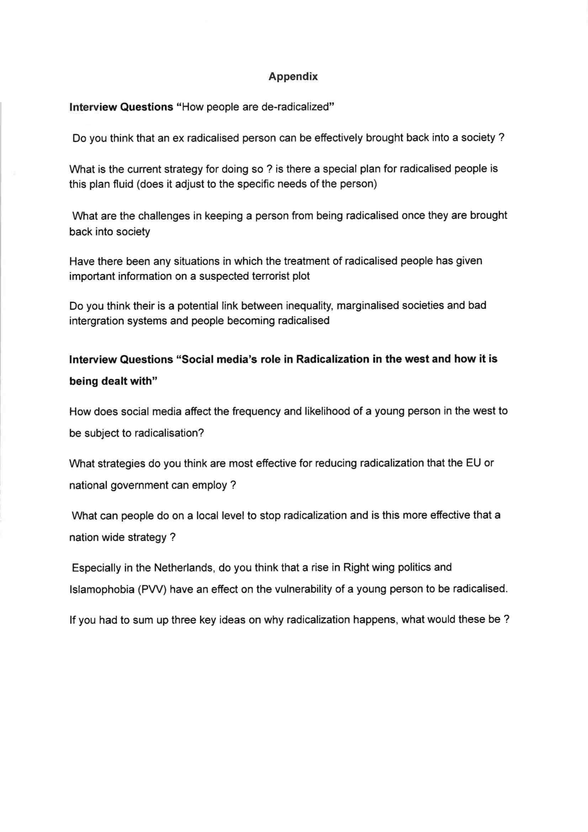

**Grades and Comments for Sample Engagement Activity:**

To what extent can soft power be used as a means of de-radicalization for extremist Islam in the West?

|  |  |  |
| --- | --- | --- |
| **Criteria** | **Marks awarded** | **Marks available** |
| Criterion A | 4 | 4 |
| Criterion B | 4 | 4 |
| Criterion C | 5 | 6 |
| Criterion D | 5 | 6 |
| **Total marks** | **18** | **20** |

**Examiner comments**

**Criterion A**

Political issue clear (how soft power is used for radicalization and whether this can also be done for de-radicalization of extremists) and connected to course content. Engagement (interviewing rehabilitation worker and a criminal investigator) connected to the political issue. Personal interest is clear.

**Criterion B**

Effective explanation of engagement, detailing the student’s position before and after the engagement.

**Criterion C**

Terminology thoroughly explored as is the connection between “radicalization” and “soft power”. Role of globalization (internet) and inequality (socio-economic disparity) are identified and analysed. Almost all statements are justified through references to engagement or additional sources (apart from “hard power”).

**Criterion D**

The report constantly goes back and forth between engagement and additional sources, and they enrich each other. Engagement explores different perspectives (social worker versus investigator).

**Overall**

Well thought through and meaningful engagement and identification and exploration of the specific political issue (though ”extremist Islam in the west” appears broad). Effective synthesis and clear reflections on lessons learned. Specific terminology thoroughly explored.

**Engagement Activity Proposal/Approval Form**

**1. What political issue have you chosen and what key concept(s) is it based on? Write a short paragraph to explain.**

**2. Why are you interested in this political issue? Write a short paragraph to explain.**

**3. What different perspectives are there on this issue? List them below with a sentence to briefly explain each one. (This could be different Levels of Analysis or different group/individual perspectives).**

1. **What opportunities are there for engagement in this political issue? List them below with as much detail as possible. *What engagement activities are available at a local, community, national, regional, international and global level about this issue? (Not all levels need to be covered)***
2. **Checklist—Initial each box to ensure that your EA will cover each of the following components:**

**Does the Engagement Activity allow me to experience the dynamics of real world politics and do so in a participatory way?**

**Do the political issues focused on affect a community or a society in which I have some stake or experience in?**

VV

**Does the engagement involve contact with others who are also interested in , or have a stake in, the political issue?**

VV

**5. What sources (Resources, People, Events, Organizations) are available for you on your chosen political issue? Fill in the table below. List at least 5 (You may not need to use all 5, but you should be aware of and prepared to contact or complete them)**

|  |  |
| --- | --- |
| **Source** | **How is it relevant?** |
|  |  |
|  |  |
|  |  |
|  |  |
|  |  |
|  |  |
|  |  |
|  |  |
|  |  |
|  |  |

|  |
| --- |
| **Teacher’s Comments:** |